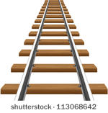

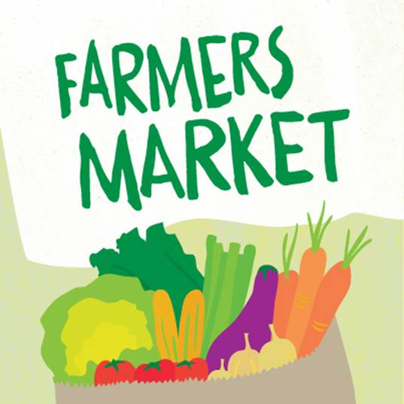

[This Photo](http://oliveandruby.com/food-blog/10-tips-get-most-your-farmers-market-experience) by Unknown Author is licensed under [CC BY-NC-SA](https://creativecommons.org/licenses/by-nc-sa/3.0/)